Response to change

Template

Please complete this section of thetemplate before doing the research.

Step 1:

Think of two change experiences you have recently experienced and on the template provided, provide an overview of what the change was.

1. A change imposed upon you – where you felt like you didn’t have a choice in the change. It can a be a small or large change; gradual or sudden; expected or unexpected.
2. An iintentional change where it was a conscious decision by you to initiate or support a change.

|  |
| --- |
| Change that was imposed on me:  It’s the time when I have to decide to explore in machine learning and Data Sceince field. I have to join Coursera, edx and Udacity. And now I am top in leaderboard at various hackathons platform |
| Change that was intentionally generated by me:  I was my final year B-tech now. I need to get a good job in Top company as per my skills. |

Step 2:

Think about and record the range of reactions you experienced (mindset/emotions and behavior) as you went through the changes – from the beginning to the end.

|  |
| --- |
| The range of reactions experienced for the change that was imposed on me was:  At the time of start competition and learning than I realized it’s very vast field, how to get good accuracy . but after 3 year I am realized I am now master of hackathon and winning hackathon on different platform. |
| The range of reactions experienced for the changed that I intentionally generated was:  When I got less accuracy than try to rebuild model by this way getting more knowledge, patient, and skills. By this way improve my accuracy. |

Step 3:

Complete the reading and research in the additional resources to get a better understanding of ‘why’ you experienced what you did and then complete the next page.

Step 4:

Now that you’ve done your research about the Change Curve, please complete the final section. Here is a reminder of the Change Curve:

The Kübler-Ross change curve

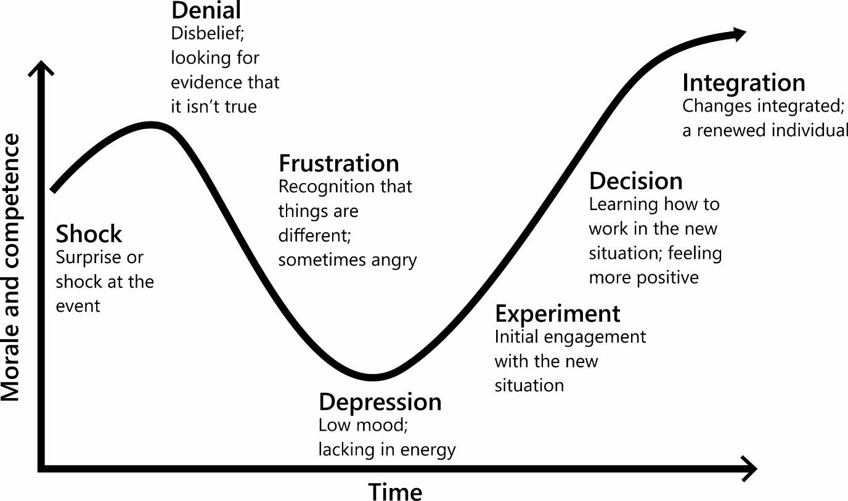

Step 5:

Identify what you have learnt from reflecting on this experience. Thinking back to the changes you wrote about earlier, identify what you have learnt from reflecting on this experience. It would also be beneficial to detail what happened at each stage of the Change Curve for you.

|  |
| --- |
| My reflections and learnings for the change that was imposed on me:  I now understand that I was in shock when I was at top 20 in google competition at kaggle at final time i got in top 95% . I really didn’t expect it. |
| My reflections and learnings for that change that I intentionally generated:  My best result is now top 2% in kaggle. |

Any final thoughts or reflections on how you could deal with change more effectively in the future?